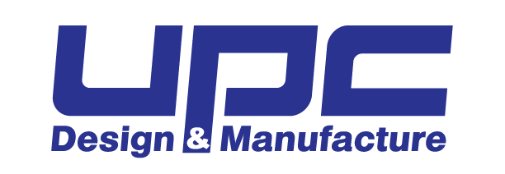
Job Title: Production Supervisor
Department: Production
Reports To: Plant Manager
Job Classification: Full Time, Non-Exempt

POSITION SUMMARY:
The Production Supervisor is a key position who oversees all manufacturing processes for their department which helps to boost revenues for the company in relation to their department. The Production Supervisor role is critical in leading the activities of their respective department and its production team on a day to day basis to contribute to the highest levels of safety, quality, customer satisfaction, and production efficiency. The Production Supervisor will collaborate and communicate with all other departments as well as provide job enrichment and growth opportunities to all levels of their team.

RESPONSIBILITIES:
- Passionately takes ownership.
- Values each team member and continuously bolsters morale.
- Positively represents UPC.
- Proactively commits to growing and expanding own skill set.
- Promotes continuous improvement projects and instills pride and ownership to their team.
- Inspires the department to achieve continuously greater results.
- Communicates continuously with production team, other departments, and leadership.
- Will take leadership in computerization of production.
- Contributes to safety.
- Is responsible for good housekeeping and maintaining department cleanliness.
- Is responsible for Quality Assurance and Quality Control.
- Will promote and educate QC Train to employees on regular basis.
- Show expertise to direct production team ensuring quality and meeting schedules.
- Organizes materials, jobs, and personnel.
- Executes job set ups prior to job run.
- Directs and promotes efficient material handling.
- Reviews quotes and ensures production within department follows schedule for costing.
- Reads and interprets “cookbooks.”
- Ensure all time studies are completed.
- Executes waste reports and “green sheets.”
- Accurately complete documents, daily reports, and end of day reports.
- Will understand the costing cycle and its relevance to all UPC manufacturing.
- Develop business acumen.
- Collaborates with Plant Manager and HR to hire top talent.
- Is responsible for time off requests, overtime, and staffing changes with advice of Plant Manager.
- Will be responsible for Paychex timecards.
- Enforce UPC policies for total compliance.
- Take direction from superiors.

EDUCATION, EXPERIENCE, & SKILL REQUIREMENTS:
- High school degree or equivalent related work experience. An associate’s degree is a plus.
- Thorough knowledge of related production processes and machines; must also have broad materials knowledge.
- 2-5 years of experience successfully leading teams in a manufacturing environment.
- Must have ability to read technical drawings.
- Basic computer competency required in Microsoft Office and for ability to work within production software programs and to create needed documentation.
- Critical thinking and troubleshooting skills used in completing tasks.
- A positive, proactive demeanor resulting in superior teamwork and collaboration with team members while demonstrating a commitment to excellence.
- Ability to read, write and speak English fluently in order to communicate effectively with team members within and external to department.

PHYSICAL REQUIREMENTS AND ENVIRONMENTAL FACTORS:
- Must be able to work in a manufacturing setting that may include environmental factors of noise, dust, chemical fumes, hot weather, and cold weather.
- Must be able to walk and stand, up to 10 hours per day.
- Must be able to lift, push, and pull up to 50 lbs. and occasionally up to 75 lbs.
- Must have physical abilities to perform production processes as needed to support the team which could include lifting, twisting, bending, reaching, and gripping.
- Must be able to communicate by using and hearing a 2-way radio and telephone.
- Have dexterity and ability to maneuver between equipment in tight working spaces.

